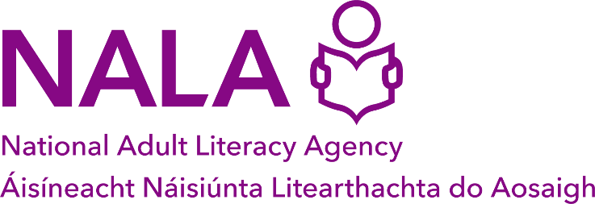

Nomination form

Please return this form to NALA by:
email: membership@nala.ie or
post: Freepost NALA, Sandford Lodge, Sandford Close, Ranelagh,
Dublin 6, D06 YF65.
Closing Date: 18 April 2025
Nominations for Director of NALA’s Board of Directors
44th Annual General Meeting (AGM) of NALA
21 May 2025
Name of Candidate:
Address of Candidate:
Proposed by:
If you represent an organisational member of NALA, please provide the name of your organisation here:
Seconded by:
If you represent an organisational member of NALA, please provide the name of your organisation here:

